Indented tail: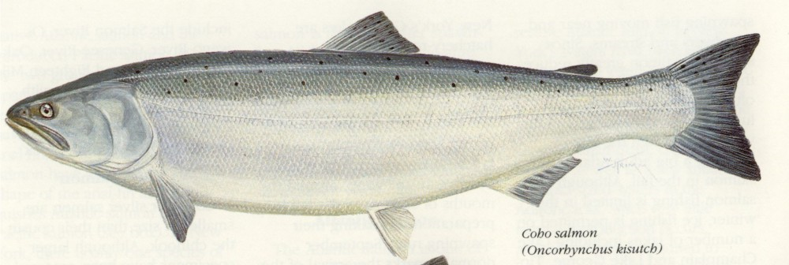

<http://pond.dnr.cornell.edu/nyfish/salmonidae/coho_salmon.jpg>

<http://pond.dnr.cornell.edu/nyfish/Salmonidae/salmonidae.html>

http://pond.dnr.cornell.edu/nyfish/fish.html

Rounded Tail  
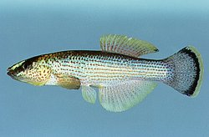

<http://img291.imageshack.us/img291/9769/minnowem4.jpg>

<http://fli.hws.edu/myplace/fishlesson_key.pdf>

good reference?

http://mcb.berkeley.edu/courses/bio1a/Lab/downloads/Bio1AL_Diveristy_Fishes.pdf

Double Truncate

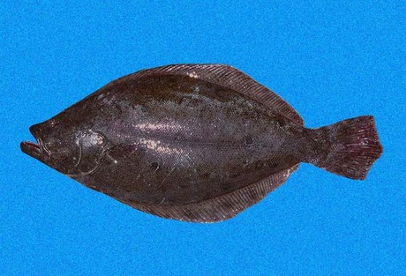http://content7.eol.org/content/2009/05/21/17/74874_large.jpg  
<http://www.discoverlife.org/IM/I_RR/0020/640/Paralichthys_adspersus,I_RR2092.jpg>  
 Paralichthys_adspersus  
http://www.discoverlife.org/mp/20p?see=I_RR2092&res=640  
<http://www.discoverlife.org/IM/I_RR/0020/640/Hippoglossina,I_RR2085.jpg>

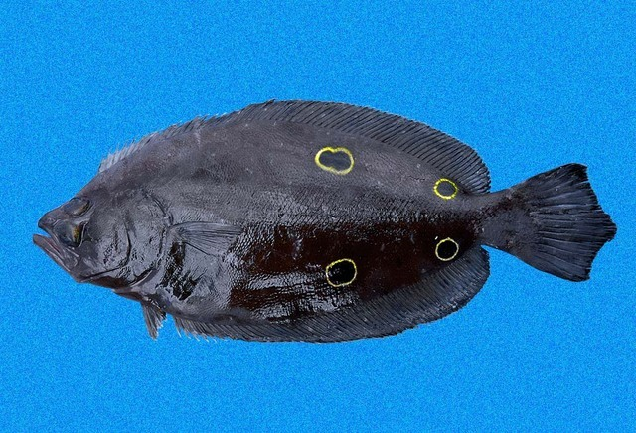

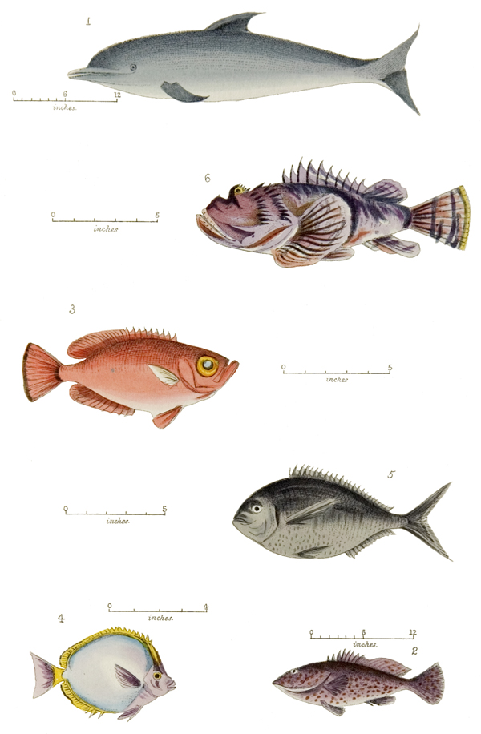http://www.bweaver.nom.sh/j_melliss/pl_19.jpg

Square Caudal Fin

<http://www.in.gov/dnr/fishwild/3599.htm>

Forked Caudal Fin

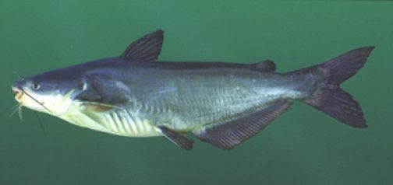

<http://main.reeltaleslodge.com/show_image_NpAdvSinglePhoto.php?filename=/2009/07/catfishblue400.jpg&cat=17&pid=410&cache=false>  
Gephyrocercal  
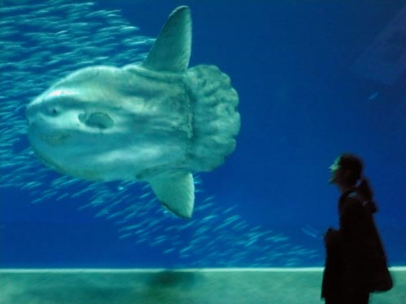  
<http://www.greyongrey.com/blog/images/kim_sun_fish.jpg>

Heterocercal

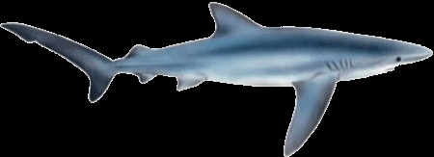  
<http://www.whitewatercharters.co.uk/images/sharks/species/blue-shark-1-m.gif>

Lunate

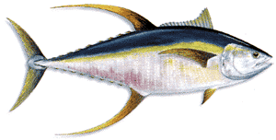

<http://www.girlscharters.com/images/YellowfinTuna.gif>

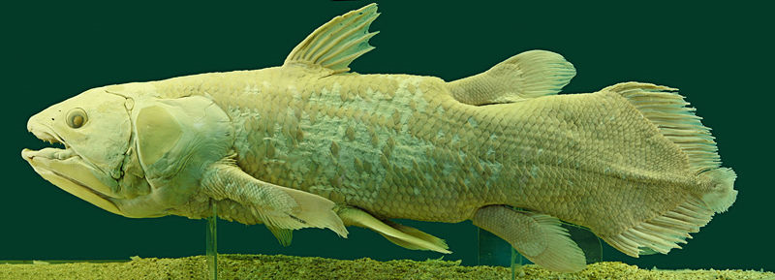

<http://en.wikipedia.org/wiki/File:Latimeria_Chalumnae_-_Coelacanth_-_NHMW.jpg>

Protocercal

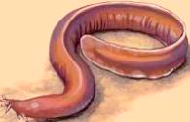

<http://204.193.113.203/ssImages/1768/medium1.jpg>

http://204.193.113.203/TeacherWeb/RossheimBarry/joshl/Fishes.aspx

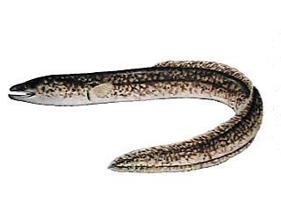

http://www.meer.org/M23.htm

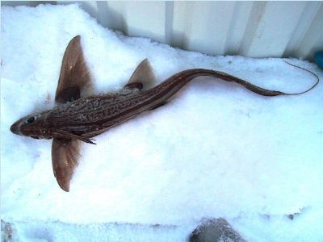http://www.thejump.net/id/ratfish.htm

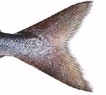

[**http://www.dailykos.com/story/2007/9/21/175817/861**](http://www.dailykos.com/story/2007/9/21/175817/861)

[**http://www.planetcatfish.com/shanesworld/shanesworld.php?article_id=378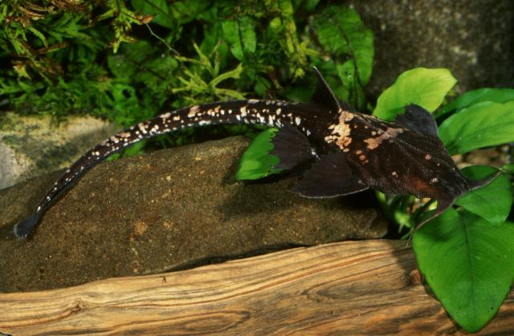**](http://www.planetcatfish.com/shanesworld/shanesworld.php?article_id=378)

**Skeletal Structures**[**http://www.elp.manchester.ac.uk/pub_projects/2003/MNZO0MLK/lecture6.htm**](http://www.elp.manchester.ac.uk/pub_projects/2003/MNZO0MLK/lecture6.htm)

some authors classify every eel-like tail as protocercal. They're ignoring the internal [structure](http://everything2.com/title/structure) and focusing only on the general [form](http://everything2.com/title/form).  
symmetrical, with the [notochord](http://everything2.com/title/notochord) reaching the end of the tail. The fin is symmetrical and continuous around the tail lobe. Examples are the [hagfish](http://everything2.com/title/hagfish) and [lamprey](http://everything2.com/title/lamprey) (*[Agnatha](http://everything2.com/title/Agnatha" \o "Agnatha)*).